Principals – approve your school’s application
- Follow the link in the email notification to go straight to your school’s application.

Go to Inside the department and add The Arts Unit Community tile to essentials for easy access.

- Select your school’s application number starting A-000 from the homepage.
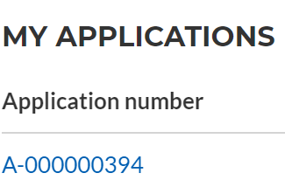
You can also go to ‘Programs’ and select the relevant program page to find your school’s application and more information.

- Select ‘Principal endorsement’ on the top right. 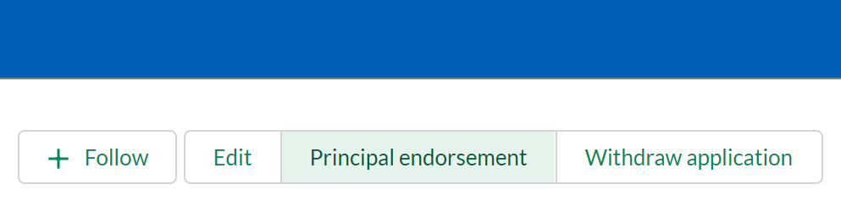
- Choose ‘Approved’ and include any comments. Choose Next, then Finish. The application status is now submitted.
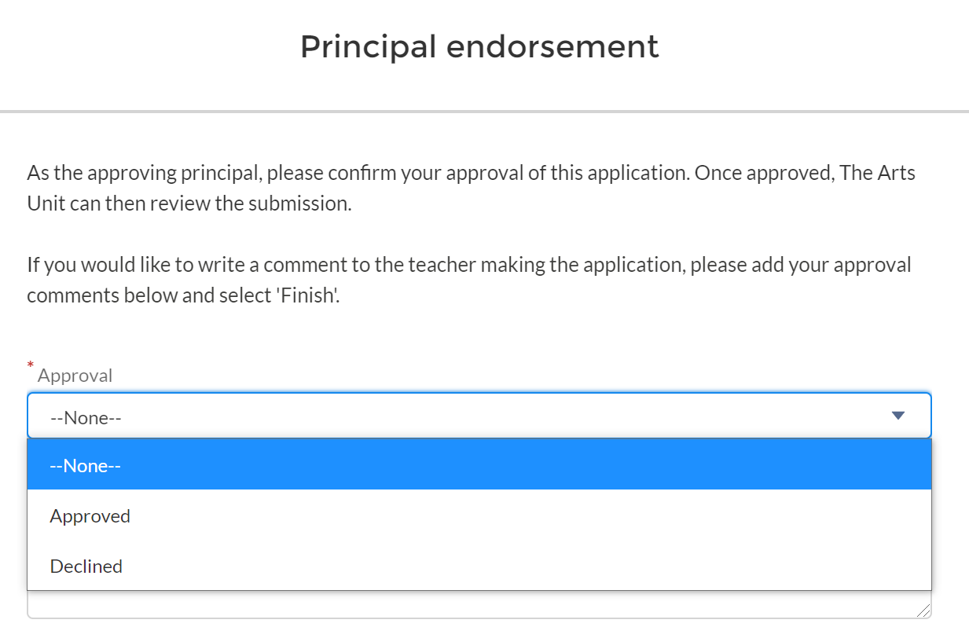

Help & support
Please contact the relevant program for enquiries.
For IT help with TAU Community portal, please log an EdConnect remedy request or email tausupport@det.nsw.edu.au.

